Language Models: Deep Dive into BERT
Unlocking the power of language models
Introduction
Clive Humby, in 2006 rightly said, “Data is the new oil”. With data being present everywhere, it has never been more valuable. Almost all companies have large amounts of textual data and are looking at ways to draw sense out of it. With the amount of data increasing exponentially, researchers are moving towards large language models (LLMs) to help them better utilise the data.
What is a Large Language Model?
A LLM can be defined as a deep learning algorithm that can perform a variety of Natural Language Processing (NLP) tasks. These models use transformers and are trained on massive amounts of data. This enables an LLM to perform tasks such as translation, question-answering, and name entity recognition on textual data. These models are trained on huge corpora of data such as Wikipedia, GitHub, etc which allows them to adapt to different NLP tasks.
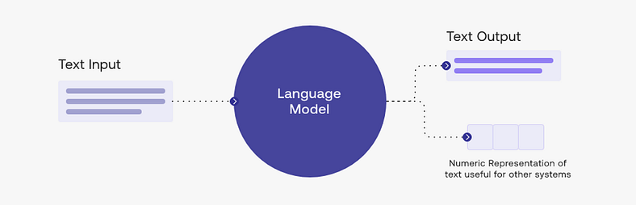
What is BERT?
BERT, which stands for Bidirectional Encoder Representations for Transformers, first came out in 2018 and took the NLP world by storm. On a high level, BERT consists of three modules. These modules are:
- Embedding: converts one hot encoding vector to an array representation. These array representations of each word represent certain features of the word. These features include the context of the word and the general meaning of the word. For example: the word “horror” will get assigned an array of integers which is very similar to the word “scary”.
- Encoders: These are transformer encoders which convert embeddings into transformer representations. The transformer representations are made by augmenting the embedding layer with positional encodings. These positional encodings contain the position of different words in the input sentence.
- Un-embedding: converts the output generated by the transformer back into one hot vector so that the loss can be generated.
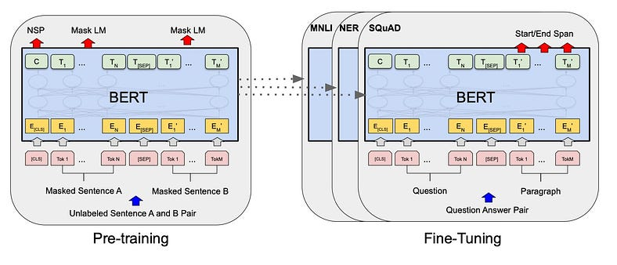
Figure Showing the BERT training process.
BERT Training
The BERT model was trained in two phases: pre-training and fine-tuning.
Pre-Training BERT
BERT is trained using two unsupervised tasks which are described below
- Masked LM: In this task, some part of the sentence is covered via a [MASK] and the model is asked to predict the masked part of the sentence given the context of the words. The training data generator chooses 15% of the tokens to be masked at random. The ith token chosen for masking is replaced with [MASK] 80% of the time or a random token 10% of the time or the original token the remaining 10% of the time.
2. Next Sentence Prediction (NSP): In this task, the model is fed with a pair of sentences (A, B) and the model is asked to predict whether the two sentences occurred sequentially or not in the training corpus. For training purposes, 50% of the time sentences A and B do occur sequentially in the training corpus. Whereas, the remaining 50% of the time sentence A is followed by a random sentence.
Pre-training allows BERT to learn the latent representation of words and sentences in context.
Fine-Tuning BERT
Fine-tuning BERT is straightforward since the self-attention mechanism in the transformer allows BERT to downstream tasks. For each task, the task-specific inputs and outputs are plugged into BERT and all the parameters are fine-tuned end to end.
BERT Architecture
BERT model has two sizes: BERT-base with total parameters of 110M and BERT-large with total parameters of 340M. The first layer is the embedding layer, which has three components: word embedding, positional embedding and token type embedding. The token type embedding helps the model know what type of token it is. The different types of tokens used in the BERT model are:
- CLS: Represents the classification task for the NSP task.
- SEP: Represents the separation between two sentences for the NSP task.
- MASK: Represents the masked word.
- UNK: Represents the words that are out of the vocabulary.
The three outputs are added and then pushed into a normalisation layer. The normalisation layer outputs an array of vectors of dimension 768. These are then pushed into 12 Transformer encoders.
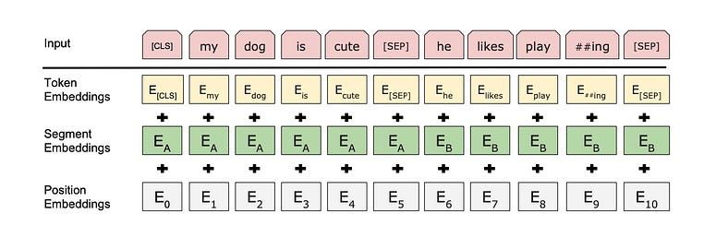
Figure Showing the Masking process.
BERT Experiments
BERT achieved state-of-the-art performance on eleven different NLP tasks. It also pushed the GLUE score (General Language understanding evaluation) to 80.5%.
For MultiNLI (Multi-Genre Natural Language Interface) the score was pushed to 86.7% which is a 4.6% absolute improvement.
For SQuAD (Stanford Question answering dataset) v1.1 Test F1 the score went to 93.2 and 83.1 for v2.0. The dataset contains 100k question-answer pairs. Given a question, the answer is in the Wikipedia text. The task was to span the answer. There was an improvement in both EM (exact matching) and F1(precision and recall of chosen word) scores.
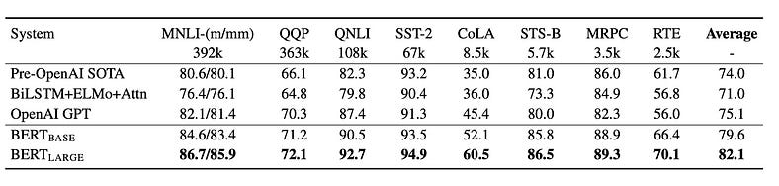
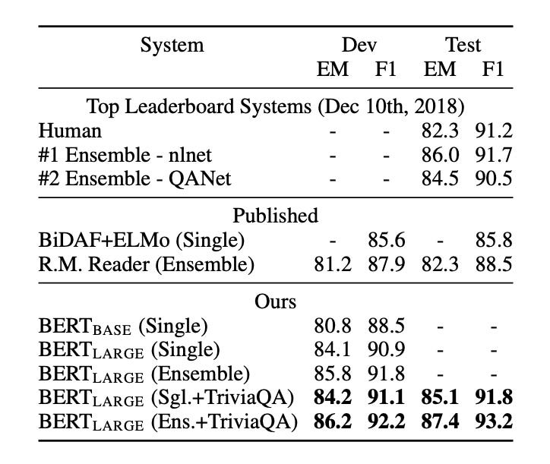
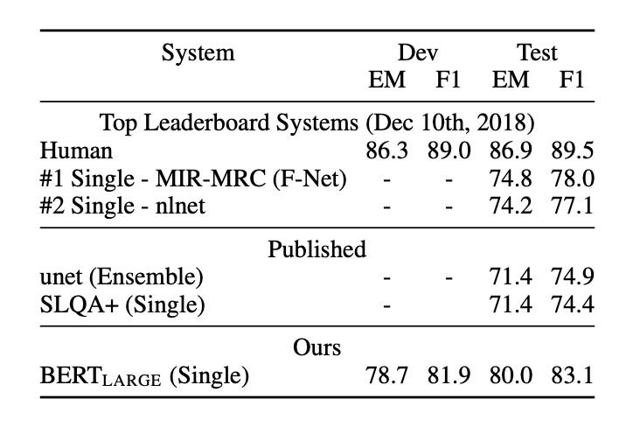
Images showing the results for various datasets.
Conclusion
BERT when it first came out in 2018 took the NLP world by storm. In contrast to other deep learning networks, BERT has already been pre-trained. Therefore, it requires very little data and can be used for an array of NLP tasks. These properties prevent it from being obsolete and even today in LLMs like GPT and RAG models we see BERT being used.

